Citi Parking & Entrance

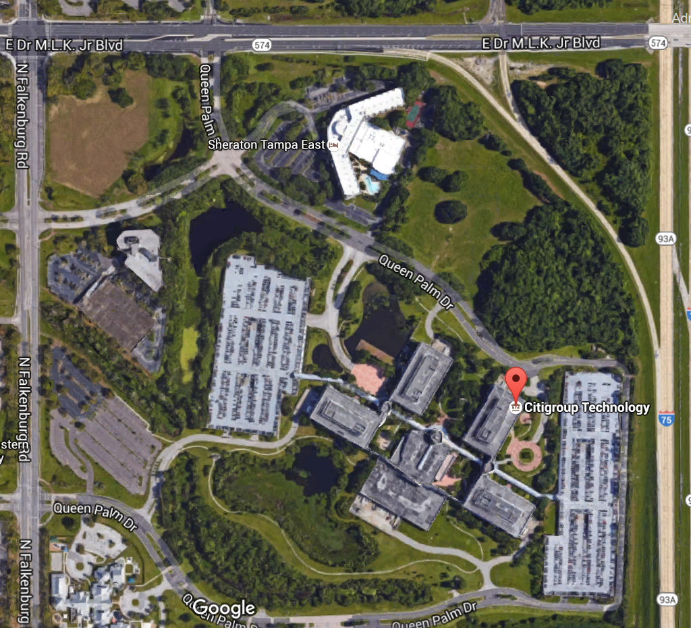

**Visitor**

**Parking**

**ENTRANCE**

**CITI**

**Guest**

**Parking**